- Challenge Name and Category: hashcrack (Cryptography)

- Difficulty/Points: Easy.

- Description: A company stored a secret message on a server which got breached due to the admin using weakly hashed passwords. Can you gain access to the secret stored within the server? Access the server using nc verbal-sleep.picoctf.net 51414

- Flag: picoCTF{UseStr0nG_h@shEs_&PaSswDs!_5b836723}

- Solution/Walkthrough:
The first step was to access the server using Net Cat by issuing the command “nc verbal-sleep.picoctf.net 63359”

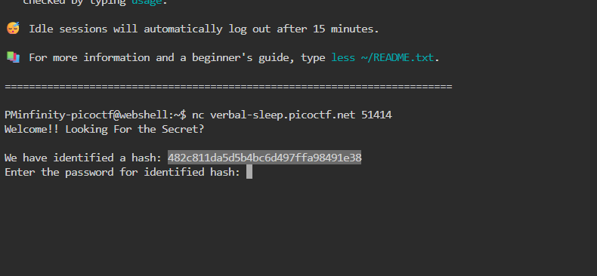
Immediately a hash was identified. I navigated to CrackStation – Online Password Hash Cracking. This tool supports; LM, NTLM, md2, md4, md5, md5(md5_hex), md5-half, sha1, sha224, sha256, sha384, sha512, ripeMD160, whirlpool, MySQL 4.1+ (sha1(sha1_bin)), QubesV3.1BackupDefaults. This hash was identified as md5, which once decrypted, resulted in the password “password123”. 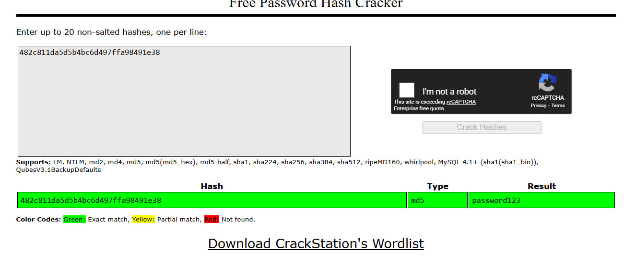
This presented up with a second hash and a second required password.

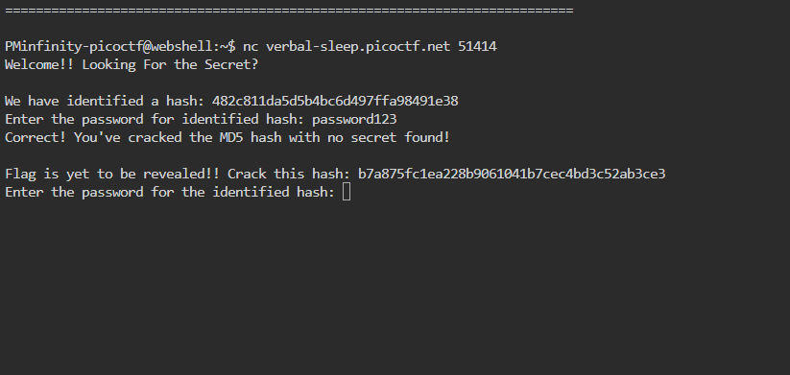
Just like with the first hash I input this one into Crack station. This hash was identified as sha1 which resulted in “letmein”, the second password required.
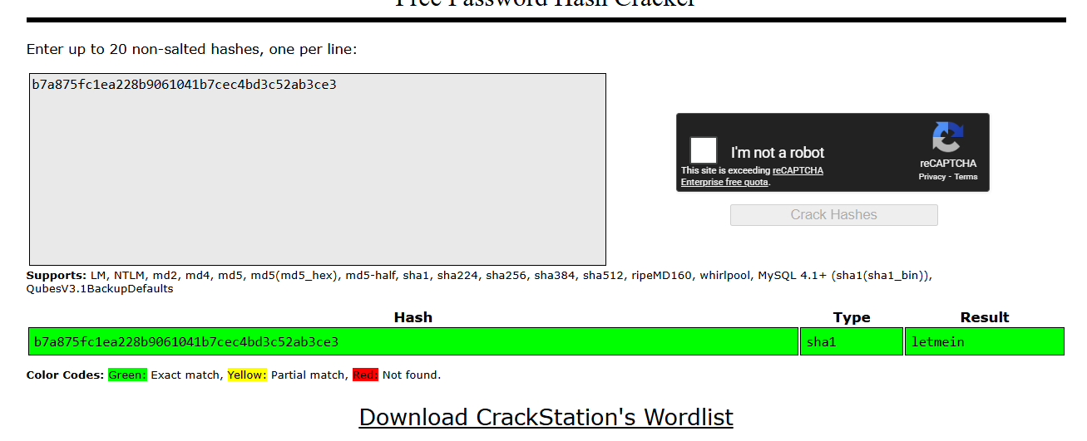
Inputting this password into the Web Shell resulted in one final hash to crack.
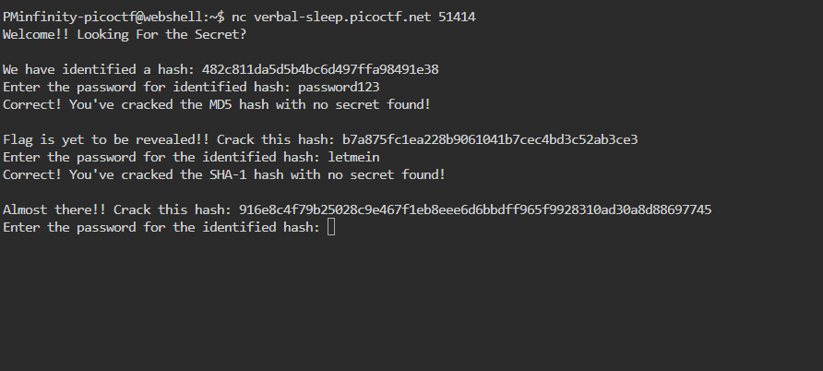
For the third and final time this hash value was input into Crack station. This final hash was sha256 which resulted in “qwerty098”


Inputting this final password resulted in obtaining the flag, picoCTF{UseStr0nG_h@shEs_&PaSswDs!_5b836723}.
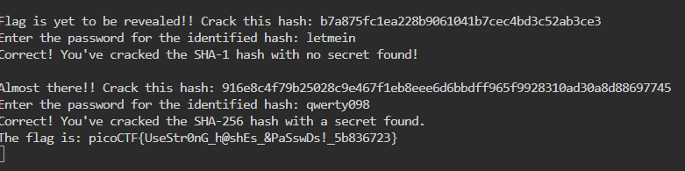

- Tools Used: Net Cat, Web Shell, Crack Station
- Initial Reconnaissance: noticing hash values and figuring out how to crack them.
- Hypothesis Formulation: I was thinking there would be one hash to crack that would result in the presentation of the flag. With this CTF three different hashes were used.
- What Worked vs. What Didn't: Inputting an incorrect password by mistake resulted in denied access and having to restart the process.

